|  |
| --- |
| AI Bootcamp: Capstone Project |
| Bank Marketing |
| Campaign Optimization |

|  |
| --- |
| Sri Bailoor  9-20-2025 |

Table of Contents

**1.** **Business Problem** 3

**Executive Summary** 3

**Business Problem Statement** 3

**Key Stakeholders** 3

**Primary Business Goals** 4

**Revenue Objectives** 4

**Operational Objectives** 4

**Strategic Objectives** 4

**Machine Learning Approach Justification** 4

**Dataset Description** 4

**Source and Credibility** 4

**Dataset Specifications** 5

**Key Variable Categories** 5

**Dataset Relevance to Business Problem** 6

**Direct Alignment** 6

**Comprehensive Coverage** 6

**Real-World Applicability** 6

**Success Measurement Framework** 6

**Technical Metrics** 6

**Business Metrics** 6

**Implementation Success Criteria** 7

**Expected Business Impact** 7

**Short-term (3-6 months)** 7

**Medium-term (6-12 months)** 7

**Long-term (12+ months)** 7

**2. Problem-Solving Process** 8

**1. Data Acquisition and Understanding** 8

**Data Acquisition Strategy** 8

**Exploratory Data Analysis (EDA) Framework** 8

**Initial Data Quality Assessment Plan** 9

**Preliminary Visualization Strategy** 9

**2. Data Preparation and Feature Engineering** 10

**Data Cleaning Approach** 10

**Feature Engineering Methodology** 11

**Sci-kit Learn Pipeline Implementation** 11

**3. Modeling Strategy** 12

**Algorithm Evaluation Framework** 12

**Cross-Validation Strategy** 13

**Hyperparameter Tuning Approach** 14

**Evaluation Metrics Selection and Justification** 14

**4. Results Interpretation and Communication** 15

**Business Insights Translation Framework** 15

**Visualization Strategy for Stakeholders** 15

**Non-Technical Stakeholder Communication Strategy** 16

**5. Conceptual Framework and Solution Pipeline** 17

**Solution Pipeline Flowchart** 17

**Project Dependencies and Critical Path** 17

**Risk Mitigation and Contingency Planning** 18

**3. Timeline and Project Scope** 19

**Project Timeline** 19

**Potential Challenges and Research Areas** 21

**Technical Challenges** 21

**Business Domain Challenges** 22

**Resource and Time Management Challenges** 22

# **Business Problem**

## **Executive Summary**

This project addresses the critical challenge of optimizing direct marketing campaign effectiveness for financial institutions through predictive analytics. By leveraging machine learning to identify high-probability prospects for term deposit subscriptions, we aim to significantly improve campaign ROI, reduce marketing waste, and enhance customer targeting precision.

## **Business Problem Statement**

**Core Challenge**: Traditional mass marketing approaches for financial products result in low conversion rates, high customer acquisition costs, and inefficient resource allocation. The Bank Marketing Dataset shows a baseline conversion rate of approximately 11% for the Portuguese bank’s term deposit campaigns, indicating significant room for improvement through better targeting.

**Specific Issues include**:

* Inefficient allocation of marketing resources across diverse customer segments
* High cost per successful conversion due to untargeted outreach
* Limited ability to identify optimal timing and customer characteristics for campaign success
* Lack of data-driven insights to guide strategic marketing decisions

## **Key Stakeholders**

* **Chief Marketing Officer**: Responsible for campaign ROI and marketing budget optimization
* **Head of Retail Banking**: Accountable for deposit growth and customer acquisition targets
* **Campaign Managers**: Tactical execution of marketing initiatives and resource allocation
* **Data Analytics Team**: Implementation and maintenance of predictive models
* **Chief Financial Officer**: Concerned with marketing spend efficiency and revenue impact
* **Customer Relationship Managers**: Direct customer interaction and follow-up activities
* **Compliance Team**: Ensuring marketing practices meet regulatory requirements

## **Primary Business Goals**

### **Revenue Objectives**

* **Increase term deposit subscription rates** by 25-40% above current baseline (11%)
* **Reduce customer acquisition cost** by 30% through improved targeting precision
* **Optimize marketing budget allocation** across customer segments and channels

### **Operational Objectives**

* **Enhance campaign efficiency** by focusing efforts on high-probability prospects
* **Improve resource utilization** in call centers and marketing teams
* **Enable data-driven decision making** for future campaign strategies

### **Strategic Objectives**

* **Develop sustainable competitive advantage** through advanced analytics capabilities
* **Build customer intelligence platform** for long-term relationship management
* **Create scalable framework** applicable to other financial products

## **Machine Learning Approach Justification**

**Pattern Recognition**: Customer behavior patterns for financial product adoption are complex and non-linear, requiring sophisticated algorithms to identify subtle relationships between demographic, economic, and behavioral variables.

**Scale and Complexity**: With thousands of customers and multiple variables, traditional statistical approaches cannot efficiently process and identify optimal customer segments.

**Continuous Learning**: Machine learning models can adapt to changing market conditions, customer preferences, and economic factors, maintaining relevance over time.

**Predictive Power**: Unlike descriptive analytics, ML enables proactive identification of prospects before campaign launch, allowing strategic resource allocation.

**Personalization Capability**: Advanced algorithms can create individual risk scores and propensity models, enabling highly targeted marketing approaches.

## **Dataset Description**

### **Source and Credibility**

* **Source**: UCI Machine Learning Repository - Bank Marketing Dataset
* **Origin**: Direct marketing campaigns of a Portuguese banking institution
* **Collection Period**: May 2008 to November 2010
* **Academic Validation**: Peer-reviewed and widely used in machine learning research

### **Dataset Specifications**

* **Size**: 45,211 records (instances)
* **Features**: 20 input variables plus 1 target variable
* **Target Variable**: Binary classification (yes/no for term deposit subscription)
* **Data Quality**: Clean, structured dataset with minimal missing values

### **Key Variable Categories**

#### **Customer Demographics**

* **Age**: Customer age (numeric)
* **Job**: Type of job (12 categories: admin, blue-collar, entrepreneur, etc.)
* **Marital Status**: marital status (divorced, married, single)
* **Education**: education level (basic.4y, basic.6y, basic.9y, high school, university, etc.)

#### **Financial Information**

* **Default**: Has credit in default? (binary: yes/no)
* **Housing**: Has housing loan? (binary: yes/no)
* **Loan**: Has personal loan? (binary: yes/no)

#### **Campaign Details**

* **Contact**: Contact communication type (cellular, telephone)
* **Month**: Last contact month of year
* **Day_of_week**: Last contact day of the week
* **Duration**: Last contact duration in seconds
* **Campaign**: Number of contacts performed during this campaign
* **Pdays**: Number of days since client was last contacted from previous campaign
* **Previous**: Number of contacts performed before this campaign
* **Poutcome**: Outcome of previous marketing campaign

#### **Economic Context**

* **Emp.var.rate**: Employment variation rate (quarterly indicator)
* **Cons.price.idx**: Consumer price index (monthly indicator)
* **Cons.conf.idx**: Consumer confidence index (monthly indicator)
* **Euribor3m**: Euribor 3 month rate (daily indicator)
* **Nr.employed**: Number of employees (quarterly indicator)

## **Dataset Relevance to Business Problem**

### **Direct Alignment**

The dataset directly addresses our core business challenge by providing historical campaign performance data with customer characteristics and outcomes, enabling us to build predictive models for future campaign success.

### **Comprehensive Coverage**

The dataset includes all critical dimensions for marketing optimization:

* **Customer profiling** through demographics and financial status
* **Campaign effectiveness** through contact history and timing
* **Economic context** for market condition considerations
* **Clear success metrics** through binary subscription outcomes

### **Real-World Applicability**

Originating from actual banking campaigns ensures the insights and patterns discovered will be applicable to similar financial services marketing challenges.

## **Success Measurement Framework**

### **Technical Metrics**

#### **Model Performance**

* **Primary**: Precision (minimize false positives to reduce wasted contacts)
* **Secondary**: Recall (capture maximum number of potential subscribers)
* **Balanced**: F1-Score for overall model effectiveness
* **Threshold**: AUC-ROC > 0.80 for deployment consideration

#### **Model Reliability**

* **Cross-validation accuracy**: >85% across multiple folds
* **Feature stability**: Consistent feature importance across time periods
* **Generalization**: Performance maintenance on holdout test set

### **Business Metrics**

#### **Campaign Effectiveness**

* **Conversion Rate Improvement**: Target 25-40% increase over 11% baseline
* **Cost Per Acquisition Reduction**: 30% decrease in customer acquisition costs
* **Campaign ROI**: Minimum 3:1 return on marketing investment

#### **Operational Efficiency**

* **Contact Optimization**: 40% reduction in unsuccessful contacts
* **Resource Utilization**: Improved allocation of call center and marketing staff
* **Time to Market**: Faster campaign deployment through automated prospect scoring

#### **Strategic Impact**

* **Revenue Growth**: Measurable increase in term deposit portfolio
* **Market Share**: Competitive advantage in deposit acquisition
* **Customer Insights**: Enhanced understanding of customer behavior patterns

### **Implementation Success Criteria**

* **Stakeholder Adoption**: 80% usage rate by campaign managers within 3 months
* **System Integration**: Seamless integration with existing CRM and campaign management systems
* **Scalability**: Successful application to additional financial products within 6 months

## **Expected Business Impact**

### **Short-term (3-6 months)**

* Immediate improvement in campaign targeting and conversion rates
* Reduced marketing waste and improved budget efficiency
* Enhanced customer segmentation capabilities

### **Medium-term (6-12 months)**

* Establishment of data-driven marketing culture
* Significant ROI improvement in deposit acquisition campaigns
* Development of customer intelligence platform

### **Long-term (12+ months)**

* Sustainable competitive advantage in retail banking
* Expanded analytics capabilities across product portfolio
* Foundation for advanced customer lifetime value optimization

# **2. Problem-Solving Process**

## **1. Data Acquisition and Understanding**

### **Data Acquisition Strategy**

#### **Source Access and Download**

* **Primary Source**: UCI Machine Learning Repository
* **Dataset**: Bank Marketing Dataset (bank-additional-full.csv)
* **Backup Sources**: Multiple academic mirrors and Kaggle alternative versions
* **Version Control**: Establish data versioning to track any updates or modifications

#### **Data Loading and Initial Inspection**

The code below loads a version of the Bank Marketing dataset directly from a CSV file using pandas, and then prints its shape and memory usage. This is a common approach when you have the data file available locally or at a known URL

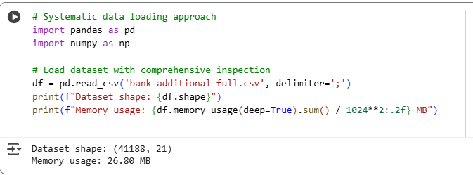

### **Exploratory Data Analysis (EDA) Framework**

#### **Structural Assessment**

* **Data Types Analysis**: Verify numeric vs categorical variable classification
* **Missing Value Audit**: Comprehensive null value assessment across all features
* **Duplicate Detection**: Identify and quantify duplicate records
* **Data Range Validation**: Check for outliers and impossible values

#### **Univariate Analysis**

* **Target Variable Distribution**: Baseline conversion rate analysis (yes/no ratio)
* **Categorical Variables**: Frequency distributions and category balance
* **Numerical Variables**: Statistical summaries, distributions, and outlier detection
* **Temporal Patterns**: Monthly and day-of-week campaign timing analysis

#### **Bivariate and Multivariate Analysis**

* **Correlation Matrix**: Identify multicollinearity issues and feature relationships
* **Target Variable Relationships**: Chi-square tests for categorical, t-tests for numerical
* **Economic Indicator Correlations**: Understanding macroeconomic impact patterns
* **Campaign History Impact**: Previous campaign success influence analysis

### **Initial Data Quality Assessment Plan**

#### **Quality Dimensions Framework**

**Completeness Assessment**

* Missing value patterns by feature and time period
* Assessment of "unknown" categorical values as implicit missing data
* Temporal completeness across campaign periods

**Accuracy Validation**

* Range validation for numerical features (age, duration, etc.)
* Categorical value consistency and standard formats
* Economic indicator validation against external sources

**Consistency Checks**

* Cross-field validation (e.g., education level vs. job type alignment)
* Temporal consistency in campaign sequence data
* Economic indicator temporal alignment

**Timeliness Evaluation**

* Dataset coverage period assessment (May 2008 - November 2010)
* Relevance of historical economic conditions to current market

### **Preliminary Visualization Strategy**

#### **Executive Dashboard Visualizations**

* **Campaign Performance Overview**: Conversion rates by key segments
* **Customer Profile Analysis**: Demographics of successful vs. unsuccessful contacts
* **Temporal Trends**: Seasonal patterns and optimal timing identification
* **Economic Context Impact**: Macro-economic conditions vs. campaign success

#### **Technical Analysis Visualizations**

* **Correlation Heatmaps**: Feature relationship identification
* **Distribution Plots**: Understanding feature distributions and skewness
* **Box Plots**: Outlier detection and categorical variable impact
* **Scatter Plots**: Relationship exploration between continuous variables

## **2. Data Preparation and Feature Engineering**

### **Data Cleaning Approach**

#### **Missing Value Strategy**

This dictionary provides a configuration for a data preprocessing pipeline that will address missing values based on the type of feature and specific rules for certain columns. This approach allows for a standardized and configurable way to handle missing data.

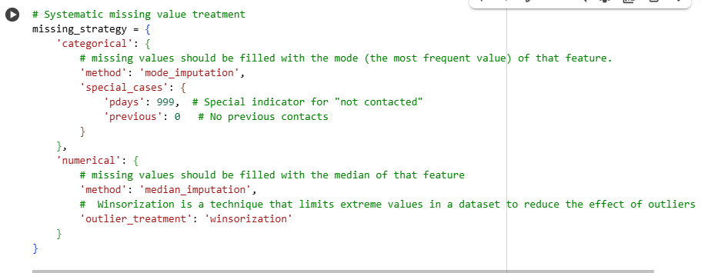

#### **Outlier Management**

* **Detection**: IQR method and statistical thresholds
* **Treatment**: Winsorization for extreme values (95th/5th percentile capping)
* **Domain-Specific Rules**: Age >18 and <100, duration >0, etc.

#### **Data Type Optimization**

* **Categorical Encoding**: Appropriate encoding strategies for different cardinalities
* **Numerical Scaling**: Preparation for algorithm requirements
* **Memory Optimization**: Efficient data types to reduce computational overhead

### **Feature Engineering Methodology**

#### **Derived Features Creation**

**Customer Behavior Features**

* **Contact Frequency Score**: Weighted scoring based on campaign and previous contacts
* **Engagement Quality**: Duration-based engagement metrics
* **Customer Lifecycle Stage**: Based on previous campaign outcomes and timing

**Economic Context Features**

* **Economic Stability Index**: Composite score from multiple economic indicators
* **Market Timing Score**: Optimal timing based on economic conditions
* **Risk Environment**: Economic uncertainty metrics

**Demographic Enhancement**

* **Life Stage Categories**: Age-education-marital status combinations
* **Financial Stability Indicators**: Loan status combinations
* **Profession Risk Categories**: Job type risk categorization

#### **Feature Interaction Engineering**

* **Age-Job Interactions**: Life stage and career stability combinations
* **Economic-Timing Interactions**: Market conditions and campaign timing
* **Previous Campaign Learning**: Historical success pattern utilization

### **Sci-kit Learn Pipeline Implementation**

#### **Preprocessing Pipeline Architecture**

The ColumnTransformer is a powerful tool from the sklearn.compose module used for applying different preprocessing steps to different columns of your dataset. It's particularly useful when you have a mix of numerical and categorical features that require different handling.

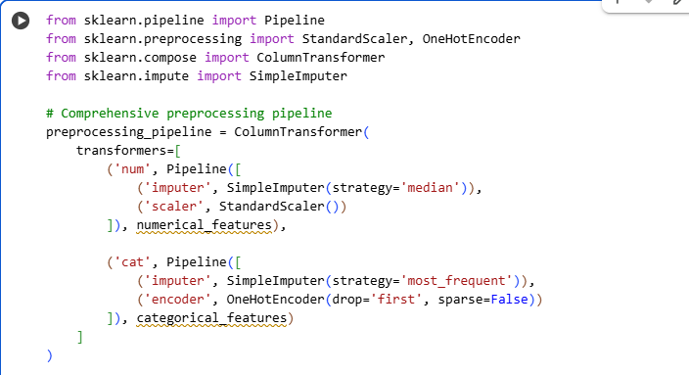

In summary, this ColumnTransformer sets up a preprocessing pipeline that will apply median imputation and standardization to numerical columns, and mode imputation and one-hot encoding to categorical columns. You would then apply this preprocessing_pipeline to your data before training a machine learning model.

#### **Feature Selection Integration**

* **Statistical Tests**: Chi-square for categorical, f_regression for numerical
* **Recursive Feature Elimination**: Algorithm-specific feature importance
* **Variance Threshold**: Removal of low-variance features
* **Domain Knowledge Integration**: Business logic-driven feature retention

## **3. Modeling Strategy**

### **Algorithm Evaluation Framework**

#### **Primary Algorithms (Minimum 3 Required)**

**1. Logistic Regression**

* **Rationale**: Baseline interpretable model with probability outputs
* **Strengths**: Coefficient interpretation, regulatory compliance, fast training
* **Configuration**: L1/L2 regularization, class weight balancing
* **Hyperparameters**: C (regularization strength), solver, max_iter

**2. Random Forest Classifier**

* **Rationale**: Ensemble method handling mixed data types effectively
* **Strengths**: Feature importance, non-linear relationships, robust to outliers
* **Configuration**: Bootstrap sampling, feature subsampling
* **Hyperparameters**: n_estimators, max_depth, min_samples_split, min_samples_leaf

**3. Gradient Boosting Classifier (XGBoost)**

* **Rationale**: State-of-the-art performance for structured data
* **Strengths**: Handling missing values, feature interactions, superior accuracy
* **Configuration**: Early stopping, GPU acceleration if available
* **Hyperparameters**: learning_rate, max_depth, n_estimators, subsample, colsample_bytree

**4. Support Vector Machine (SVM)**

* **Rationale**: Alternative approach for high-dimensional data
* **Strengths**: Effective with kernel tricks, memory efficient
* **Configuration**: RBF and linear kernels
* **Hyperparameters**: C, gamma, kernel selection

### **Cross-Validation Strategy**

#### **Stratified K-Fold Implementation**

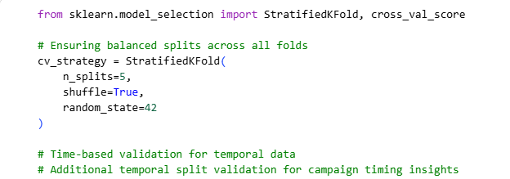

This code sets up a StratifiedKFold object for cross-validation, which will be used to evaluate the performance of a machine learning model in a way that accounts for potential class imbalance. I also plan to incorporate time-based validation methods, which would be relevant given the nature of the bank marketing dataset.

#### **Validation Framework**

* **Primary**: 5-fold stratified cross-validation for model selection
* **Temporal Validation**: Time-based splits to assess temporal stability
* **Final Holdout**: 20% test set for final model evaluation
* **Bootstrap Sampling**: Confidence intervals for performance metrics

### **Hyperparameter Tuning Approach**

#### **Grid Search Strategy**

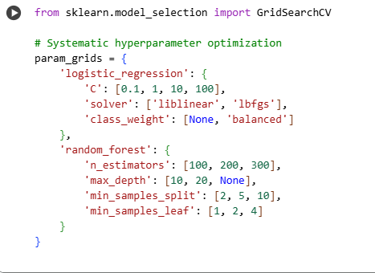

In essence, this code cell is preparing the search space for hyperparameter tuning for Logistic Regression and Random Forest models. The param_grids dictionary serves as a blueprint for GridSearchCV to explore different hyperparameter settings and find the optimal ones for my models.

#### **Bayesian Optimization Alternative**

* **Advanced Tuning**: Optuna or scikit-optimize for complex hyperparameter spaces
* **Efficiency**: Intelligent search over high-dimensional parameter spaces
* **Early Stopping**: Pruning unpromising trials to save computational resources

### **Evaluation Metrics Selection and Justification**

#### **Primary Business-Focused Metrics**

**Precision (Primary)**

* **Business Justification**: Minimizes false positives, reducing wasted marketing contacts
* **Cost Impact**: Direct relationship to marketing efficiency and budget optimization
* **Target**: >0.75 to ensure quality prospect identification

**Recall (Secondary)**

* **Business Justification**: Captures maximum revenue opportunity
* **Revenue Impact**: Identifies all potential customers willing to subscribe
* **Balance**: Trade-off with precision based on campaign capacity

**F1-Score (Balanced)**

* **Business Justification**: Harmonic mean provides balanced optimization
* **Decision Making**: Single metric for model comparison and selection
* **Target**: >0.65 for deployment consideration

#### **Additional Technical Metrics**

* **AUC-ROC**: Overall model discrimination ability across all thresholds
* **Precision-Recall Curve**: Performance across different business scenarios
* **Calibration Plots**: Probability prediction reliability
* **Confusion Matrix**: Detailed error analysis and business impact assessment

## **4. Results Interpretation and Communication**

### **Business Insights Translation Framework**

#### **Model Results to Business Language**

* **Probability Scores → Customer Propensity Rankings**: Convert model outputs to actionable customer prioritization
* **Feature Importance → Marketing Insights**: Transform technical coefficients into campaign strategy recommendations
* **Performance Metrics → ROI Projections**: Translate accuracy metrics into revenue impact estimates

#### **Actionable Recommendation Development**

* **Customer Segmentation**: High/Medium/Low propensity scoring for campaign targeting
* **Optimal Timing**: Best months/days for campaign launches based on historical patterns
* **Contact Strategy**: Recommended number of contacts and communication channels
* **Budget Allocation**: Resource distribution across customer segments

### **Visualization Strategy for Stakeholders**

#### **Executive Dashboard Components**

The Dashboard would contain the following:

* ROI_projection_chart
* customer_segmentation_pie
* monthly_opportunity_heatmap
* campaign_efficiency_comparison

**ROI Impact Visualization**

* Before/After campaign performance comparison
* Cost savings through improved targeting
* Revenue opportunity identification

**Customer Insight Dashboards**

* Demographic profiles of high-propensity customers
* Geographic and temporal opportunity mapping
* Channel effectiveness analysis

#### **Technical Performance Visualization**

* **Model Comparison Charts**: Performance metrics across all algorithms
* **Feature Importance Plots**: Business-relevant variable impact ranking
* **Learning Curves**: Model stability and data sufficiency analysis
* **Calibration Plots**: Prediction reliability assessment

### **Non-Technical Stakeholder Communication Strategy**

#### **Conceptual Framework Explanation**

* **Analogy-Based Learning**: Compare ML models to familiar business processes
* **Progressive Disclosure**: Layer technical complexity based on audience expertise
* **Visual Storytelling**: Use infographics and process flows rather than technical jargon

#### **Risk and Limitation Communication**

* **Model Limitations**: Clear explanation of what the model cannot predict
* **Data Dependencies**: Ongoing data quality requirements
* **Performance Monitoring**: Continuous evaluation and model maintenance needs

## **5. Conceptual Framework and Solution Pipeline**

### **Solution Pipeline Flowchart**



### **Project Dependencies and Critical Path**

#### **Phase 1: Data Foundation (Weeks 1-2)**

**Dependencies**:

* UCI repository access
* Computing environment setup
* Python libraries installation

**Deliverables**:

* Clean dataset with quality assessment report
* Initial EDA findings and visualization

#### **Phase 2: Feature Development (Weeks 2-3)**

**Dependencies**:

* Completion of data cleaning
* Business domain knowledge integration
* Feature engineering pipeline

**Deliverables**:

* Engineered feature set
* Feature selection rationale
* Preprocessing pipeline

#### **Phase 3: Model Development (Weeks 3-4)**

**Dependencies**:

* Prepared dataset
* Cross-validation framework
* Computing resources for hyperparameter tuning

**Deliverables**:

* Trained models with performance metrics
* Model comparison analysis
* Selected champion model

#### **Phase 4: Business Translation (Week 5)**

**Dependencies**:

* Final model selection
* Performance validation
* Business stakeholder availability

**Deliverables**:

* Executive presentation materials
* Technical documentation
* Deployment roadmap

### **Risk Mitigation and Contingency Planning**

#### **Technical Risks**

* **Data Quality Issues**: Alternative imputation strategies and external validation
* **Model Performance**: Ensemble methods and additional algorithm exploration
* **Computational Limitations**: Cloud computing resources and model simplification

#### **Business Risks**

* **Stakeholder Buy-in**: Progressive demonstrations and ROI quantification
* **Implementation Challenges**: Phased rollout and pilot program approach
* **Regulatory Compliance**: Legal review and audit trail maintenance

# **3. Timeline and Project Scope**

## **Project Timeline**

**Phase 1: Dataset Finalization and Problem Formulation - Weeks 1-2**

**Duration**: 2 weeks  
**Effort Allocation**: 15-20 hours

**Key Activities**:

* **Dataset acquisition and initial exploration**: Download and validate Bank Marketing Dataset from UCI repository, verify data integrity
* **Business problem definition refinement**: Align technical objectives with business goals, establish success criteria
* **Project repository setup**: Initialize version control, establish development environment, configure required libraries
* **Preliminary data assessment**: Basic statistical overview, identify data structure and potential challenges

**Deliverables**:

* Cleaned dataset with initial quality report
* Refined problem statement document
* Project repository with standardized structure
* Initial findings summary

**Phase 2: Exploratory Data Analysis - Weeks 2-3**

**Duration**: 1.5 weeks  
**Effort Allocation**: 20-25 hours

**Key Activities**:

* **Comprehensive data profiling**: Missing values analysis, data type validation, outlier detection
* **Statistical analysis of relationships**: Correlation analysis, chi-square tests for categorical variables, ANOVA for continuous variables
* **Creation of informative visualizations**: Distribution plots, correlation heatmaps, business-relevant dashboards
* **Documentation of insights**: Pattern identification, hypothesis generation for modeling phase

**Deliverables**:

* Complete EDA report with statistical findings
* Visualization portfolio for stakeholder communication
* Data quality assessment with remediation recommendations
* Feature relationship documentation

**Phase 3: Data Preprocessing - Weeks 3-4**

**Duration**: 1.5 weeks  
**Effort Allocation**: 18-22 hours

**Key Activities**:

* **Data cleaning implementation**: Missing value imputation, outlier treatment, data type optimization
* **Feature engineering**: Derived feature creation, interaction terms, domain-specific transformations
* **Pipeline development**: Scikit-learn pipeline construction, preprocessing automation
* **Data splitting**: Stratified train/validation/test splits with temporal considerations

**Deliverables**:

* Robust preprocessing pipeline
* Engineered feature set with documentation
* Clean, analysis-ready datasets
* Feature engineering rationale document

**Phase 4: Model Development - Weeks 4-5**

**Duration**: 2 weeks  
**Effort Allocation**: 25-30 hours

**Key Activities**:

* **Implementation of baseline models**: Logistic Regression, Random Forest, XGBoost, SVM
* **Algorithm comparison**: Performance evaluation across multiple metrics
* **Hyperparameter tuning**: Grid search and/or Bayesian optimization
* **Cross-validation**: Stratified k-fold validation with temporal stability checks

**Deliverables**:

* Trained model suite with performance benchmarks
* Hyperparameter optimization results
* Cross-validation performance reports
* Algorithm comparison analysis

**Phase 5: Model Evaluation and Refinement - Week 6**

**Duration**: 1 week  
**Effort Allocation**: 15-18 hours

**Key Activities**:

* **Final model selection**: Champion model identification based on business metrics
* **Performance evaluation on test data**: Unbiased performance assessment
* **Business metric calculation**: ROI projections, cost-benefit analysis
* **Interpretation of results**: Feature importance analysis, prediction insights

**Deliverables**:

* Champion model with final performance metrics
* Business impact assessment report
* Model interpretation and insights document
* Prediction confidence analysis

**Phase 6: Documentation and Reporting - Week 7**

**Duration**: 1 week  
**Effort Allocation**: 12-15 hours

**Key Activities**:

* **Code commenting and cleanup**: Production-ready code documentation
* **Technical report writing**: Comprehensive methodology and results documentation
* **Executive presentation development**: Business-focused summary with actionable insights
* **Visualization refinement**: Professional charts and dashboards for stakeholders

**Deliverables**:

* Complete technical documentation
* Executive presentation materials
* Code repository with comprehensive README
* Visual storytelling assets

**Phase 7: Final Review and Submission - Week 8**

**Duration**: 0.5 weeks  
**Effort Allocation**: 8-10 hours

**Key Activities**:

* **Quality assurance**: Code review, documentation verification, reproducibility testing
* **Video recording**: Project demonstration and explanation
* **Final submission preparation**: Package all deliverables according to requirements
* **Post-project reflection**: Lessons learned documentation

**Deliverables**:

* Final project submission package
* Demonstration video
* Reflection and lessons learned document

## **Potential Challenges and Research Areas**

### **Technical Challenges**

**Class Imbalance Management**:

* **Challenge**: 11% positive class rate requires specialized handling
* **Research Needed**: SMOTE, cost-sensitive learning, threshold optimization techniques
* **Mitigation**: Multiple sampling strategies, ensemble methods, evaluation metric selection

**Feature Engineering Complexity**:

* **Challenge**: Economic indicators require domain knowledge for effective utilization
* **Research Needed**: Financial domain expertise, economic indicator relationships
* **Mitigation**: Literature review, domain expert consultation, incremental feature testing

**Model Interpretability vs. Performance Trade-off**:

* **Challenge**: Balancing black-box model accuracy with business interpretability needs
* **Research Needed**: SHAP values, LIME, permutation importance techniques
* **Mitigation**: Ensemble of interpretable and high-performance models

**Temporal Stability**:

* **Challenge**: Model performance may degrade with changing economic conditions
* **Research Needed**: Time series validation, concept drift detection
* **Mitigation**: Temporal cross-validation, economic condition normalization

### **Business Domain Challenges**

**Financial Services Regulations**:

* **Challenge**: Marketing optimization must comply with banking regulations
* **Research Needed**: GDPR, financial services marketing compliance
* **Mitigation**: Ethical AI principles, bias detection, fairness metrics

**Economic Context Integration**:

* **Challenge**: Translating macroeconomic indicators into actionable insights
* **Research Needed**: Economic theory, market condition impact on banking behavior
* **Mitigation**: Economic indicator normalization, domain expert validation

**Customer Behavior Evolution**:

* **Challenge**: Customer preferences change over time, affecting model relevance
* **Research Needed**: Customer lifecycle analysis, behavior change detection
* **Mitigation**: Regular model retraining schedules, performance monitoring

### **Resource and Time Management Challenges**

**Computational Resource Constraints**:

* **Challenge**: Hyperparameter tuning and ensemble methods require significant computation
* **Research Needed**: Efficient optimization algorithms, cloud computing options
* **Mitigation**: Smart search strategies, parallel processing, resource scheduling

**Data Quality and Availability**:

* **Challenge**: Historical dataset may have quality issues or missing contexts
* **Research Needed**: Data imputation techniques, external validation sources
* **Mitigation**: Multiple imputation strategies, sensitivity analysis

**Stakeholder Communication**:

* **Challenge**: Translating technical results into business actionable insights
* **Research Needed**: Data visualization best practices, business communication strategies
* **Mitigation**: Progressive disclosure, analogy-based explanations, visual storytelling